Noeloikeau Charlot

PHYS311

Fourier Analysis Lab Results

4/26/2017

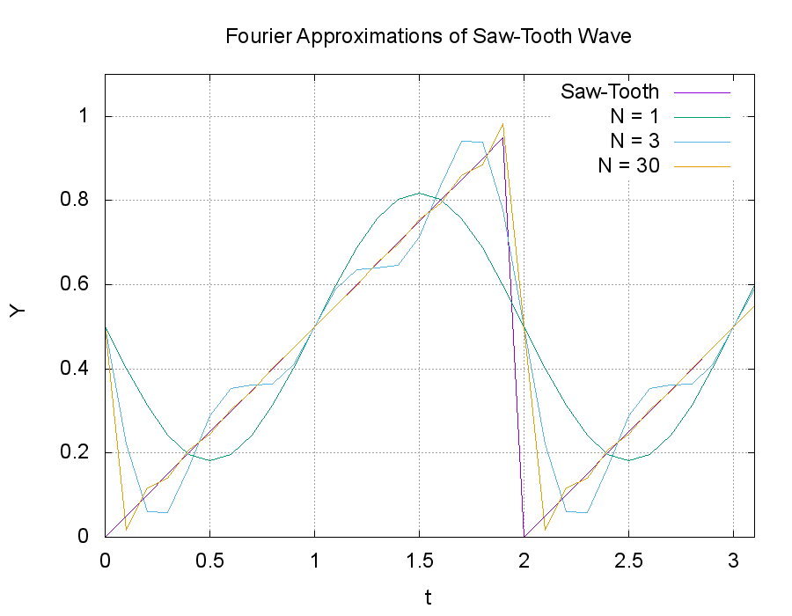

Fig. 1: Saw-tooth wave (purple) and its fourier sums having 1 term (green), 3 terms (blue), and 30 terms (orange). Coefficients used were an=0, bn=-1/(n\*pi).

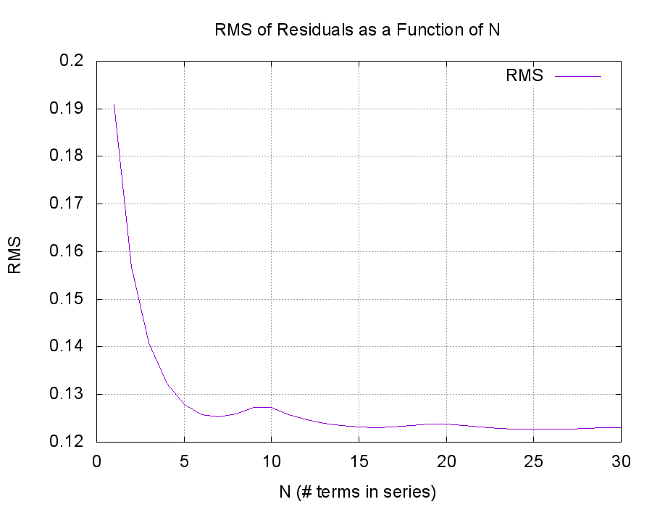

Fig. 2: Root-mean-square (RMS) residuals as a function of number of terms in the sum (N) approximating the above saw-tooth wave.

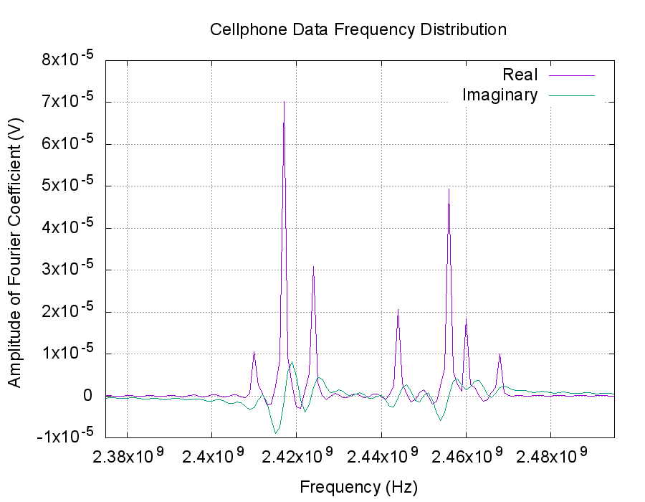

Fig. 3: Real and Imaginary components of fourier coefficients for cell-phone time series.

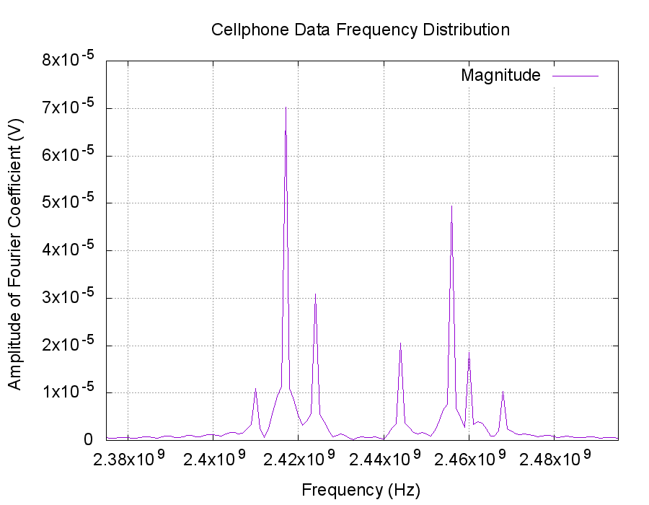

Fig. 4: Absolute magnitude of the coefficients presented above in Fig. 5.

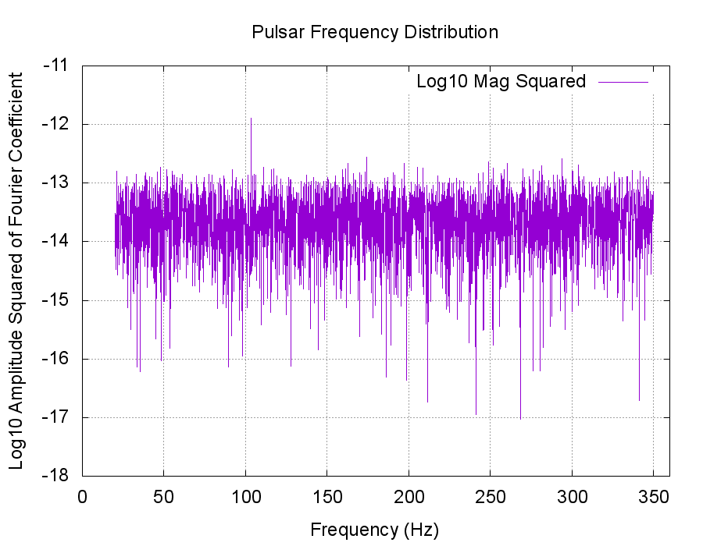

Fig. 5: Log 10 of Fourier coefficient magnitude squared as a function of frequency for a pulsar time series. Note positive spike near 100 Hz corresponding to likely pulsar frequency.

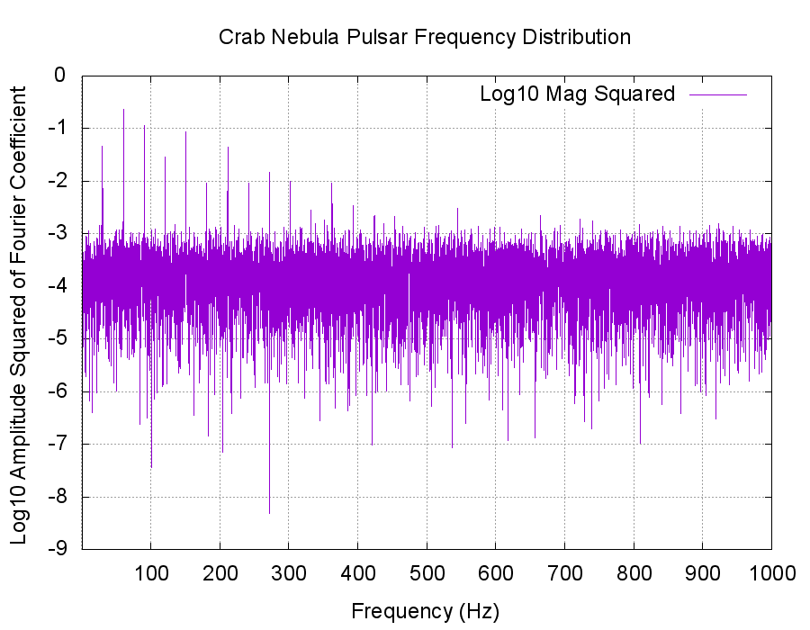

Fig. 6: Frequency distribution of fourier coefficients corresponding to time series of crab nebula pulsar having predicted frequency 30.2453Hz. Higher harmonics manifest as positive spikes past this point.

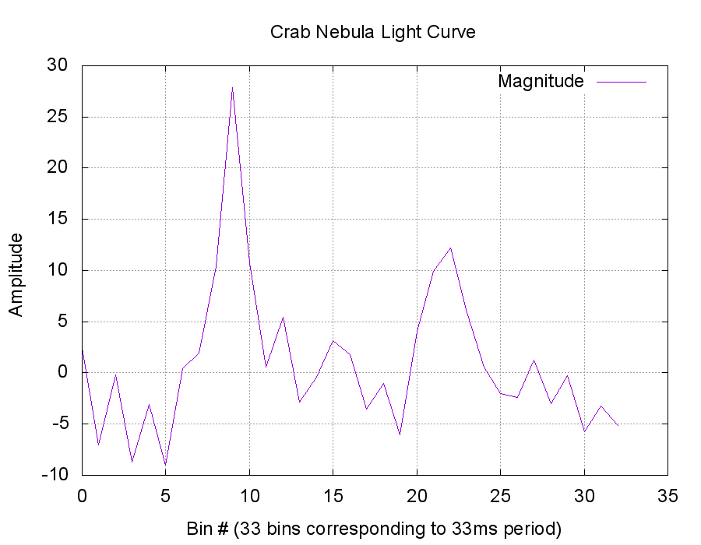

Fig. 7: Crab nebula pulsar light curve binned at 1ms intervals corresponding to 33.0532ms period.